1. Enabled future date in Customer History and Statistics.

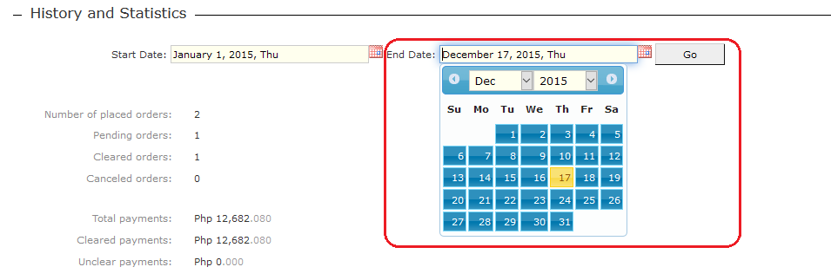

2. Enabled future date when entering Payment.

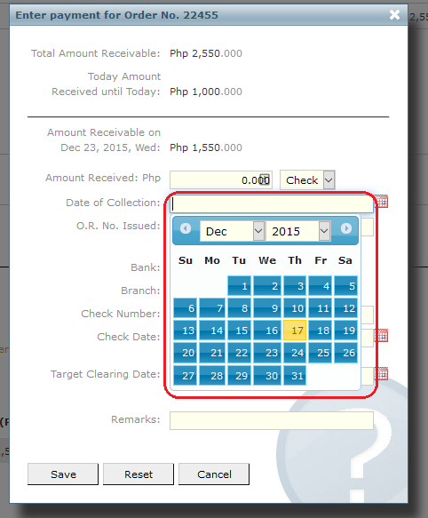

3. Enabled percentage input.

For example, if I enter “50%”, the amount will be automatically calculated when I click outside the text box.

SI/DR Price:

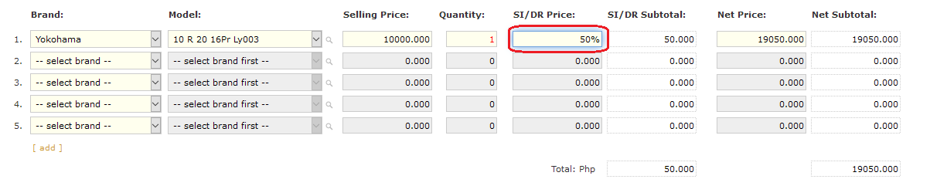

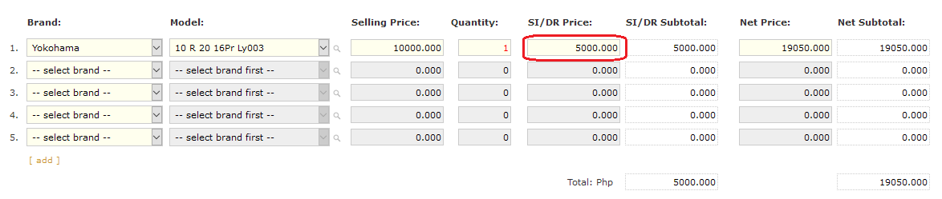

Also works in Net Price, Withholding Tax, and Installment Plan.

Net Price:

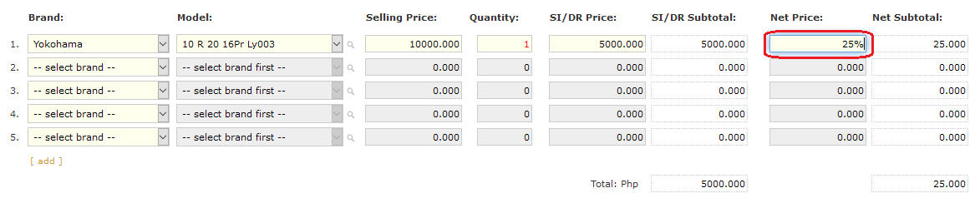

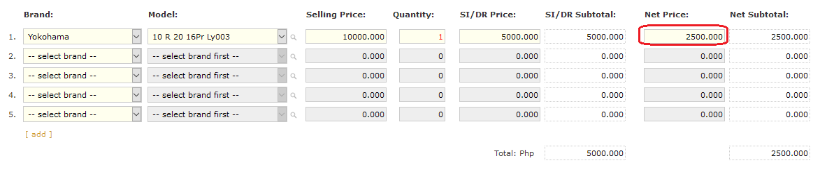

Withholding Tax:

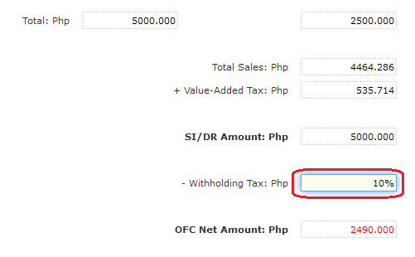

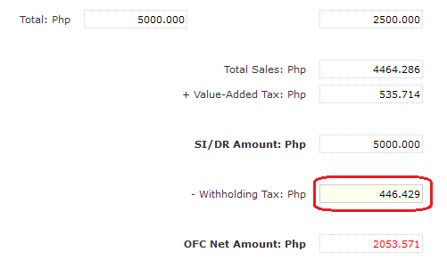

Installment Plan:

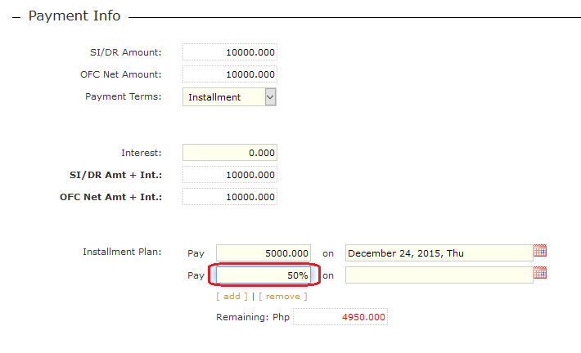

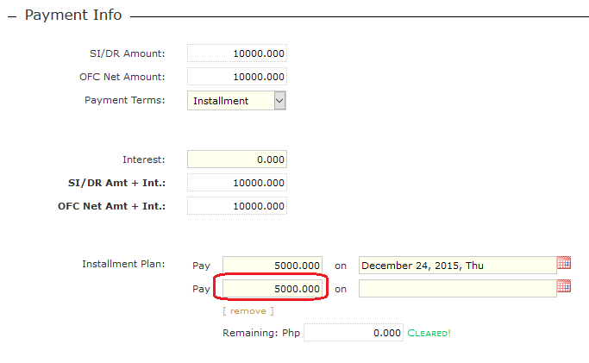

3. Display warning message if SI/DR Price or Net Price is less than Selling Price.

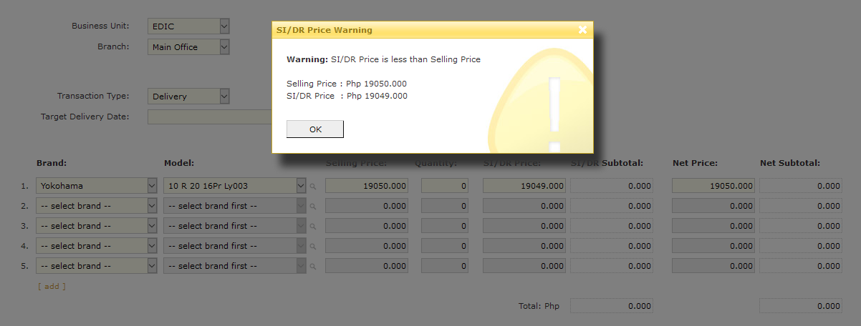

4. Enabled editing of Orders/Purchases even if the items are already delivered or payment is already made (as long as the Order/Purchase is not yet cleared).

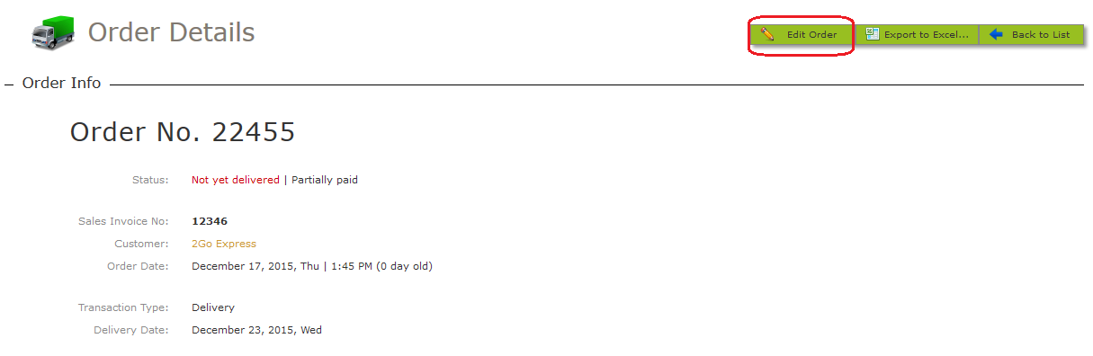

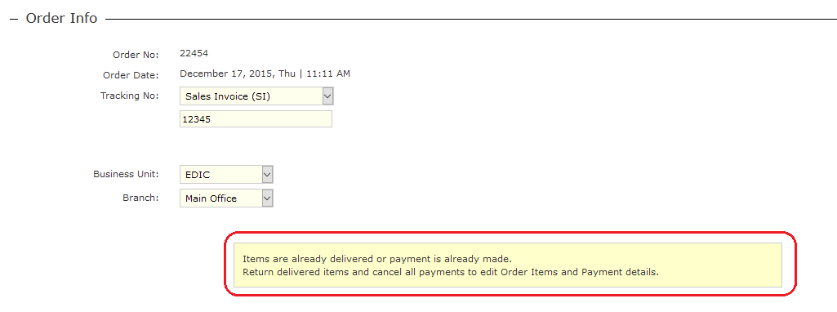

5. Fixed backup script not working due to change in date format.